# Jenkins Task-1

1. Install Jenkins and run Jenkins on port number 8081.

* Download jenkins Repo:
* sudo wget -O /etc/yum.repos.d/jenkins.repo https://pkg.jenkins.io/redhat-stable/jenkins.repo
* Import the jenkins key:
* sudo rpm --import https://pkg.jenkins.io/redhat-stable/jenkins.io-2023.key
* Update ec2
* sudo yum upgrade
* Add required dependencies for the jenkins packages
* sudo amazon-linux-extras install java-openjdk11
* Install Jenkins:
* sudo yum install jenkins

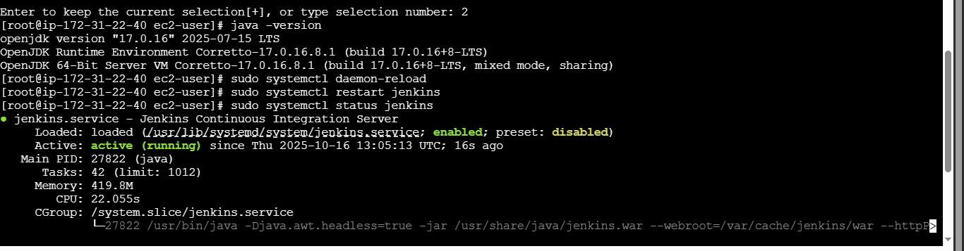

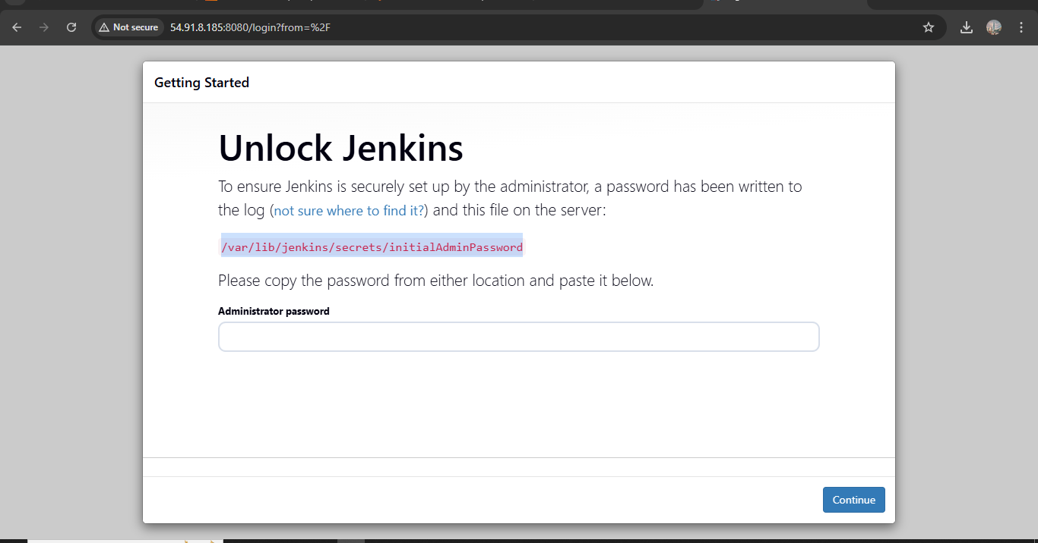

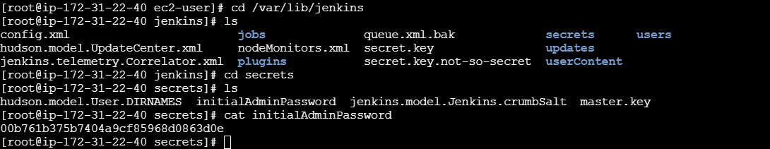

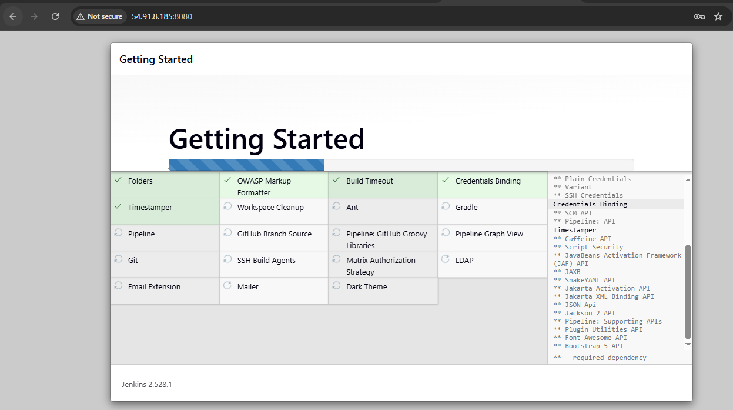

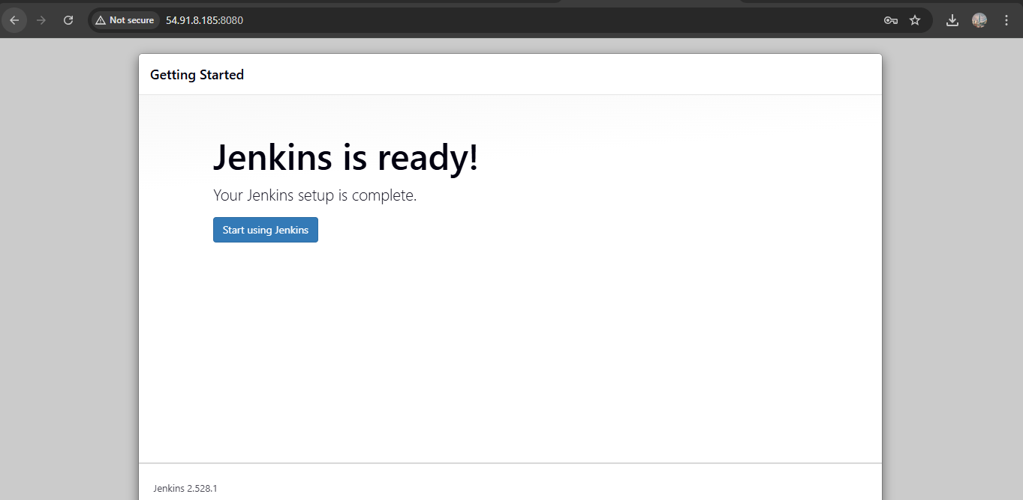

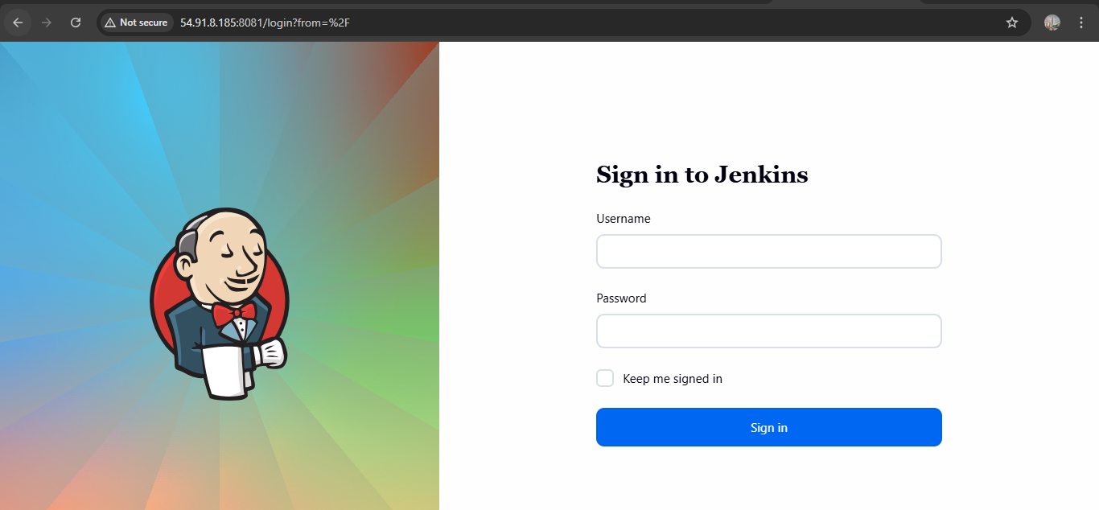

1. Secure Jenkins server

* Open ur jenkins server.
* Add a user instead of admin name.
* Then choose ur own password.
* This is the one way to secure ur account.



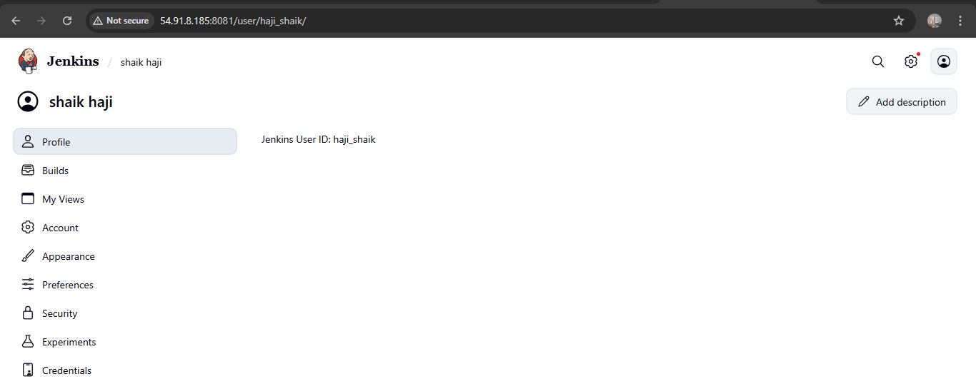

1. Create users called DevOps, Testing in Jenkins with Limited access.

* Go to ur jenkins.
* Then go to manage jenkins optins.
* Then choose plugins.

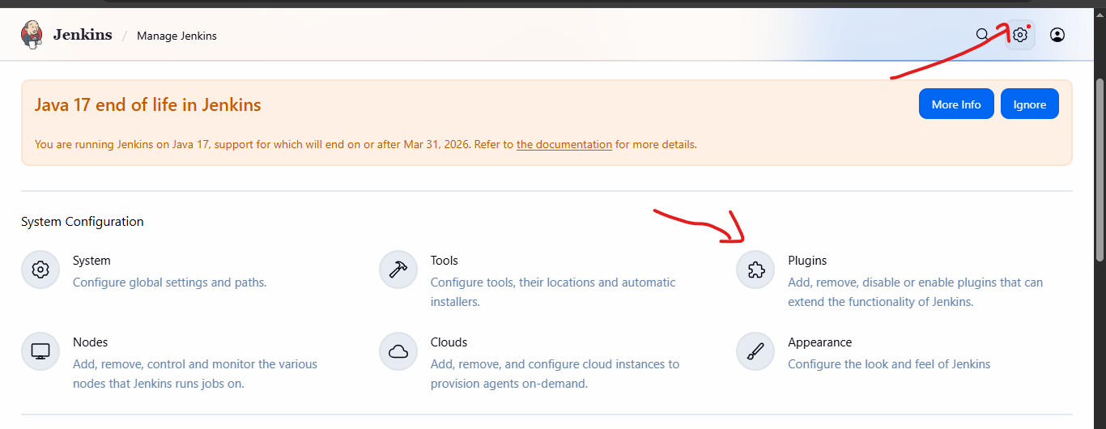

* Then choose available plugins.
* In that role-based authentication download.

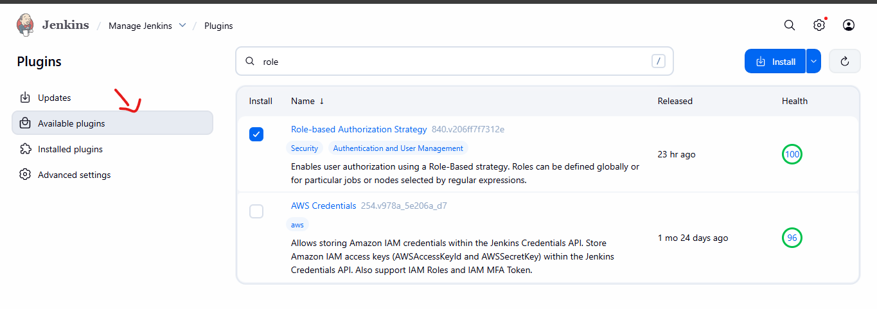

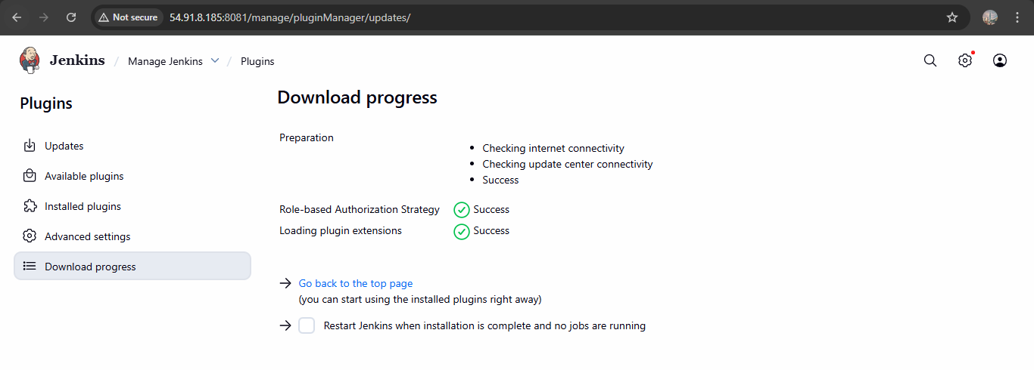

* Then go for authanticater tab.
* Then gave a permissons to the user.
* Before of that create a user first.

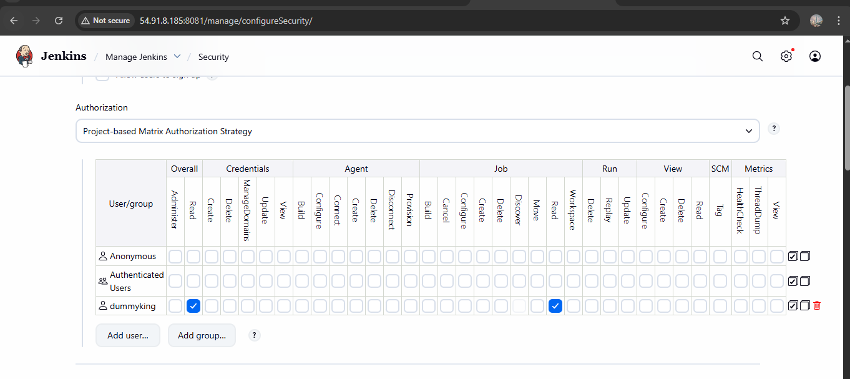

1. Configure labels and restrict the jobs to execute based on label only.

* Here the explanation about label and restrict jobs.
* Go to manage Jenkins first.
* Then go to plugins >> nd available plugins >> node label parameter >> install.
* Then in manage Jenkins >> node > check the node.
* Then go to the dashboard >> create job >> gave a URL its shows you error first.
* Then connect to the your instance nd check the git version.
* If its not available then use “yum install git -y”
* Then the error will gone.
* If is showing some error.
* Click the job nd check error in console output:

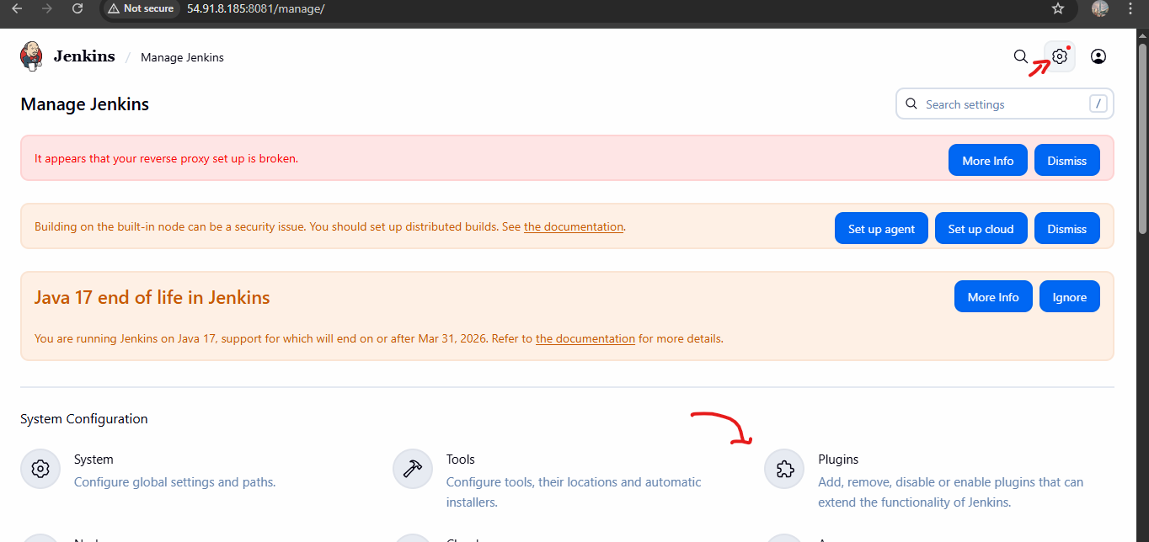

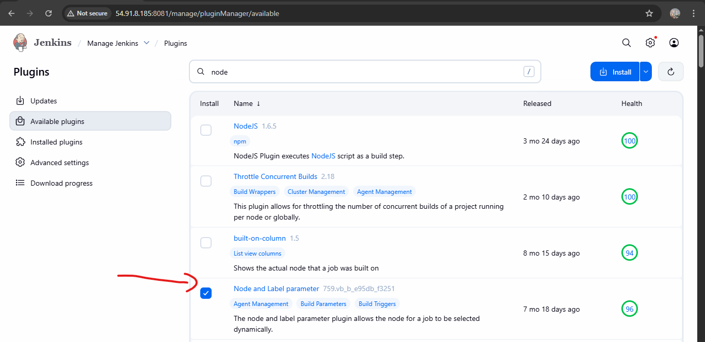

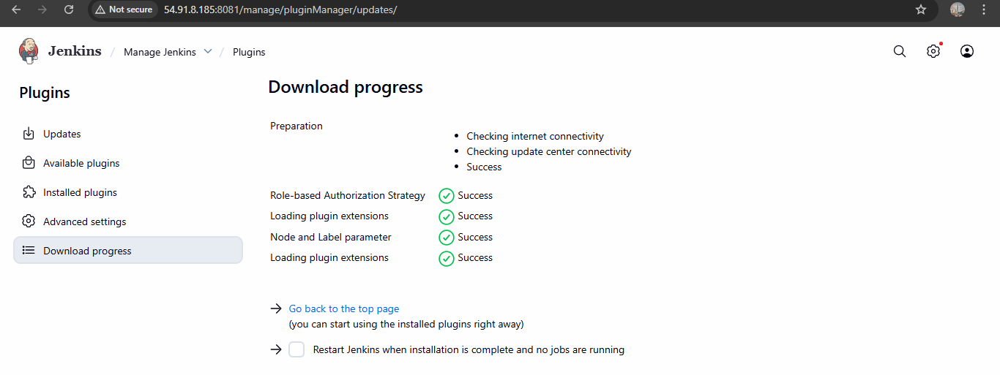

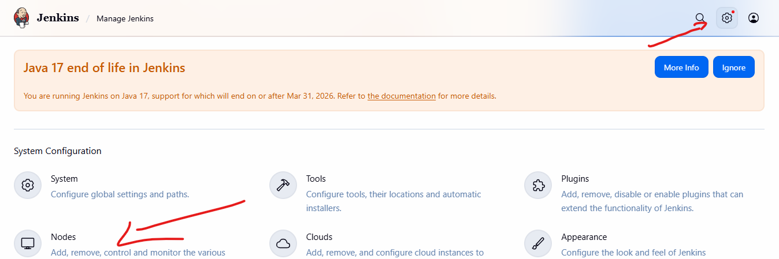

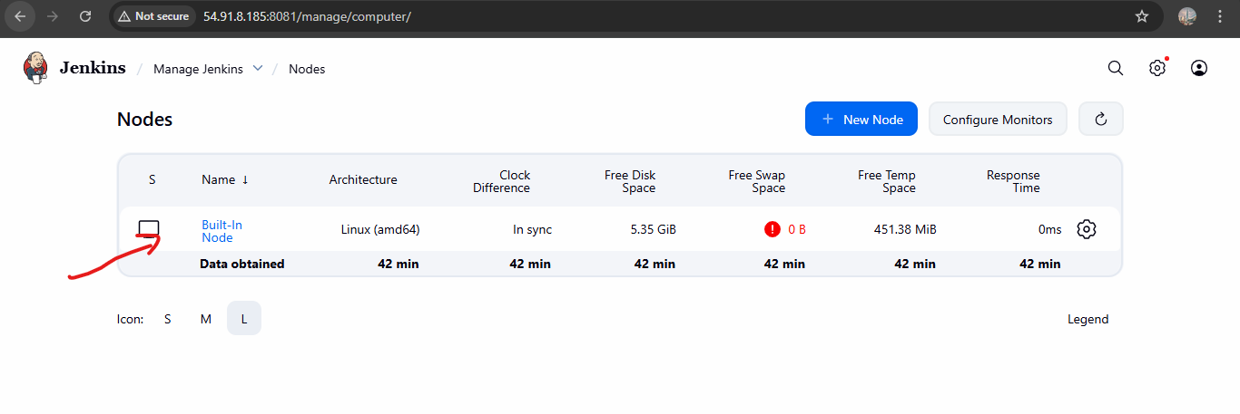

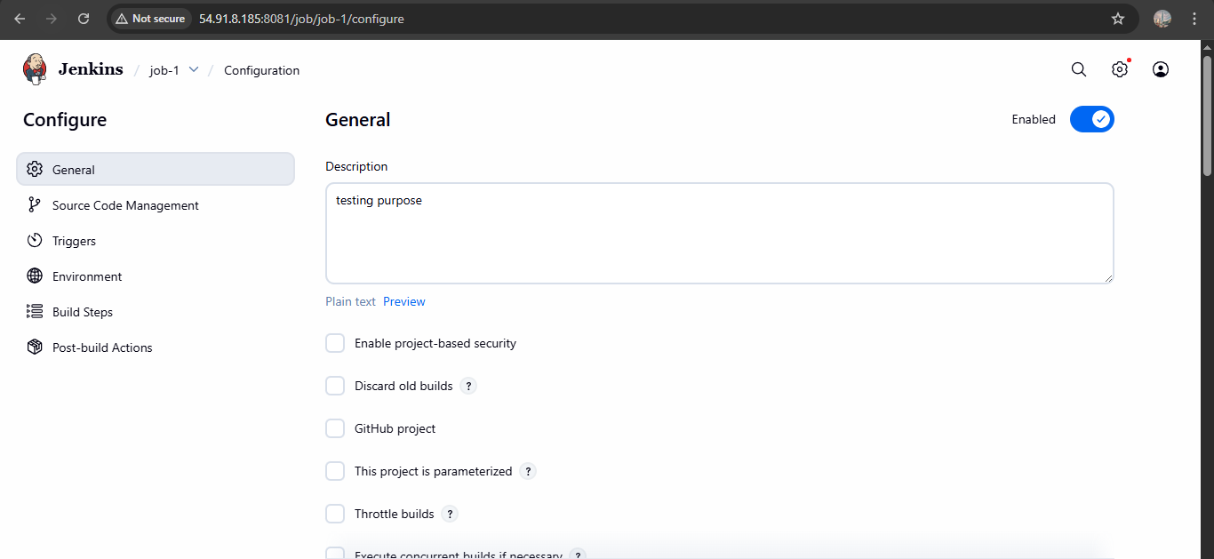

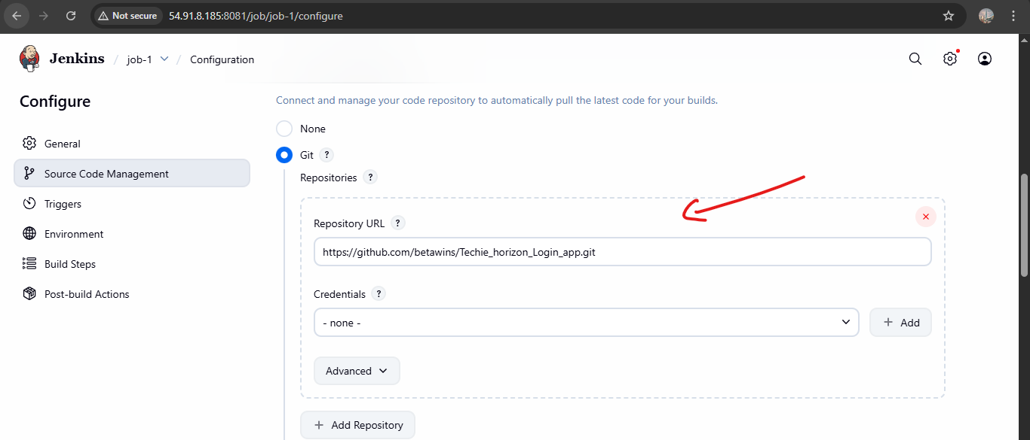

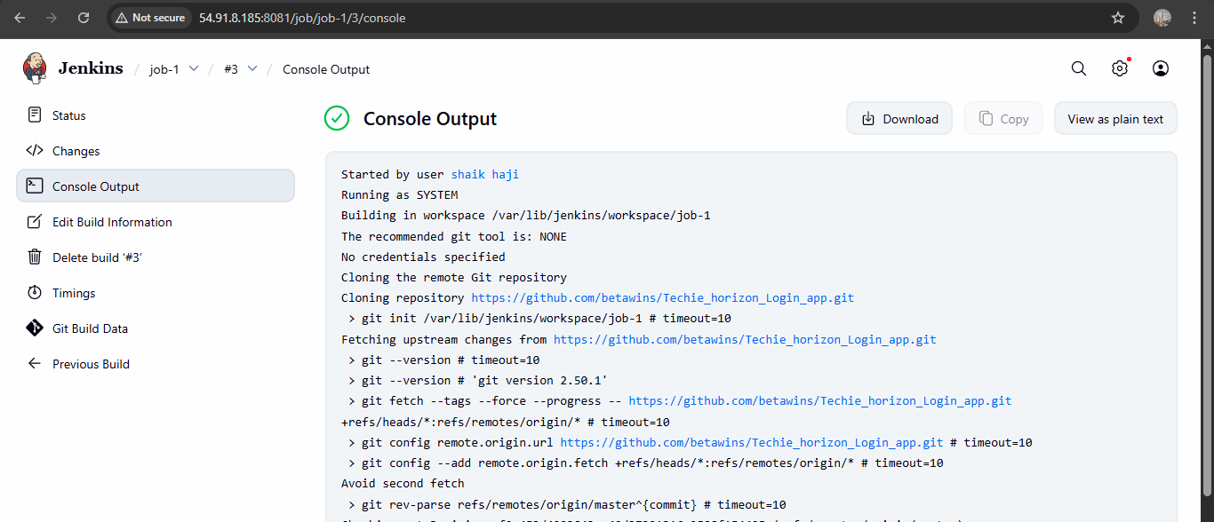

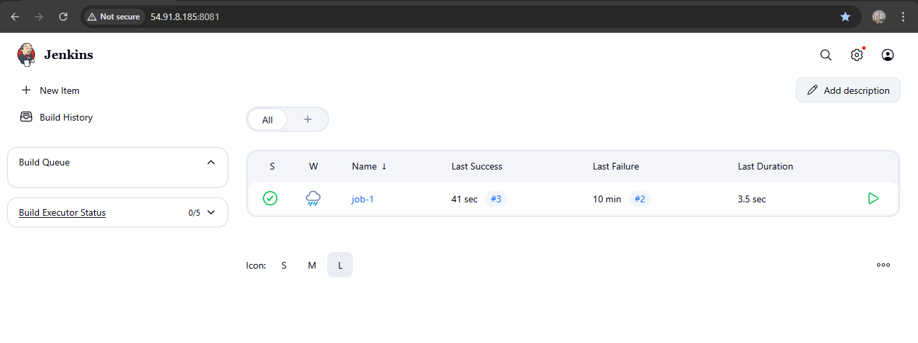

1. Create Three sample jobs using the below URL. [https://github.com/betawins/Techie_horizon_Login_app.git](https://github.com/betawins/Techie_horizon_Login_app.git" \t "https://app.slack.com/client/T03TRQ064Q0/_blank)

* Go to the dashboard of jenkins.
* Create a new item.
* Then gave a name of that.in discription.
* Nd choose git nd copy the repo url.
* And save.
* Do same thing other 2 jobs also.

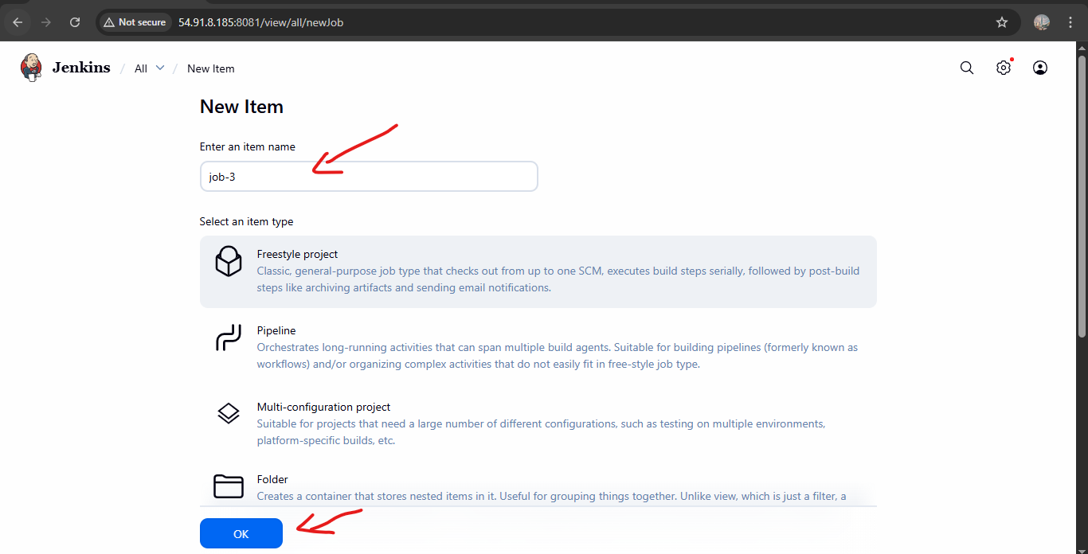

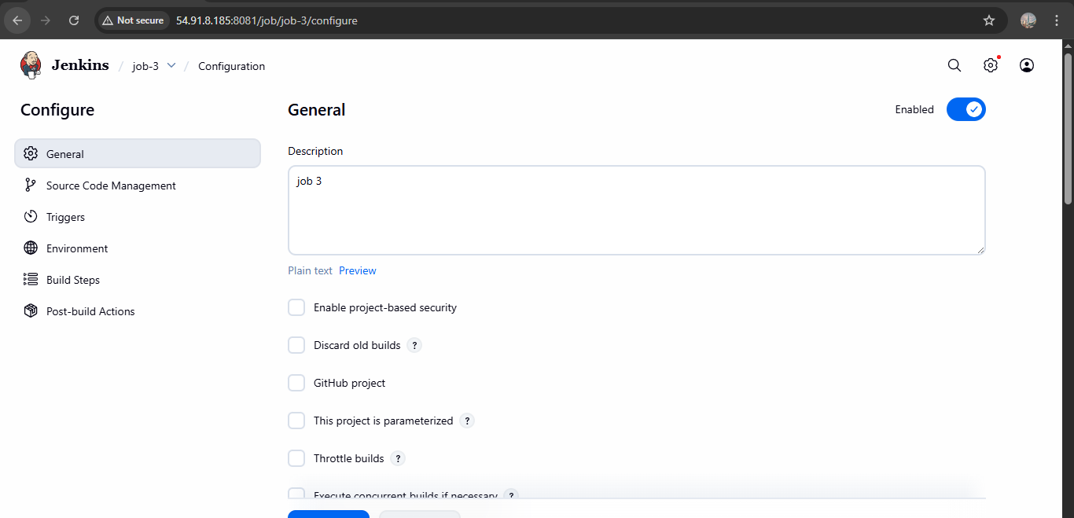

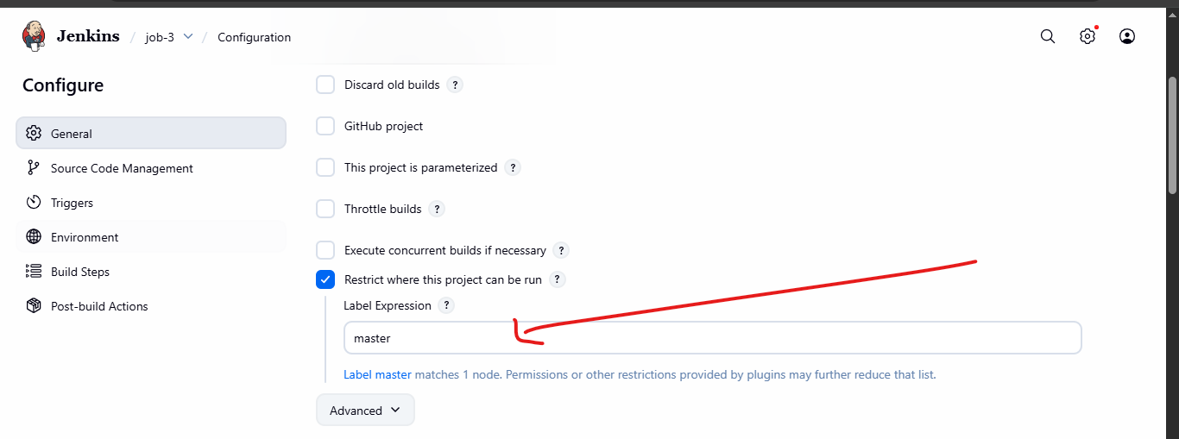

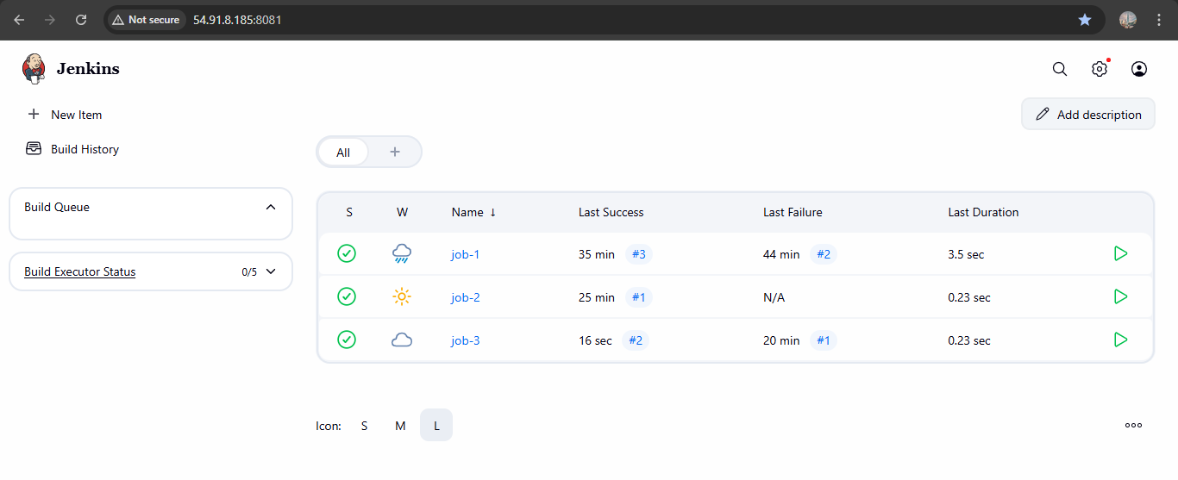

1. Create one Jenkins job using git hub Private repository.

* Go to manage jenkins.
* Then use credentials.
* Then system and create credentials
* And save it

STEP:2

* Go to jenkins dash board.
* Then create a job.
* Use git.
* Gave ur private repo http adress for that.
* Then go to build >> excute build steps >> then gave welcome note for that here the results are:

